Stroke Box - legal wording

One of the key factors that influence the outcomes of stroke patients is how fast they are treated. Physiologically what is happening is that the patient has some blockage in the brain that stops blood from supplying oxygen and nutrients, which means that the affected region is starting to die. The sooner that you can open up the blocked artery by means of clot busting drugs or by extracting the clot with a catheter the smaller the dead region and the better the outcome for the patient.

Clinical trial data illustrated below shows very clearly that the chance of a patient having a good recovery after a stroke is much better the sooner you treat a patients. For patients treated in under 90 minutes from when their symptoms started every 4th patient would have a good outcome. For patients treated after 3 – 4,5 hours the odds are much worse (every 14th patient will have a good outcome).

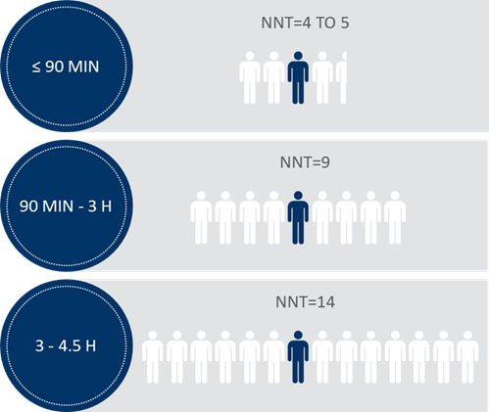

What typically happens in most stroke centres is that patients are brought in by an ambulance and taken to a CT scanner where a CT scan is performed to determine if the stroke is a ischaemic (clot) or haemorrhagic (bleeding) stroke. Once it is determined that it is a ischaemic stroke (85% of cases) the guidelines recommend specific treatment has to be given to either dissolve or remove the clot. What happens in most stroke centres currently is that they now move the patient from the CT room to either the ICU or the Stroke Unit where treatment is given. This transfer sometimes can take up to 30 minutes as the ICU or stroke units is often very far from the CT room.

Our aim is help hospitals to save this 30 minutes and in the process help the patients whose brain is busy dying. What best practice hospitals like Helsinki, Frankfurt Hoechst or Heidelberg do is they start treatment already in the CT room. This allows them to treat patients in Helsinki within 17 minutes on average from when the patient enters the door. Most of the hospitals in Europe are not even managing to treat patients within an hour, partly because they don’t treat their patients in the CT room.

Starting treatment in the CT room has implications though, because normally there are no materials available in the CT room like venous catheters, blood vials, saline and also therapy to reduce blood pressure and to stop seizures for example. It is necessary to have access to these types of materials before patients can be given thrombolysis or thrombectomy.

The idea of the stroke bag is to provide hospitals with the opportunity to carry everything with them to the CT scanner and also to be able to start treatment in the CT room. Practically how it works is that the stroke specialist will fill and hold the bag in the stroke unit. When he/she is notified of an incoming stroke patient he grabs the bag and he and his nurse heads down to the CT room. The nurses start using the cannulas, blood vials etc from the bag to get venous access, check glucose and other bloods and so forth. She would get all of these materials from the stroke bag. If BP, temperature or glucose has to be managed they also can get the necessary drugs from the stroke bag. If the patient is eligible for recanalization therapy, the doctor makes the decision and instructs the nurse to start therapy, which will also be in the stroke bag.

In short we provide hospitals with an empty bag, a list of what they have to put in the bag and also with protocols (if they don’t have protocols of their own). Hospitals fill the bag from their own stocks.

Below is an example of what this bag looks like as well as an example of what it would look like when its filled by the hospital.

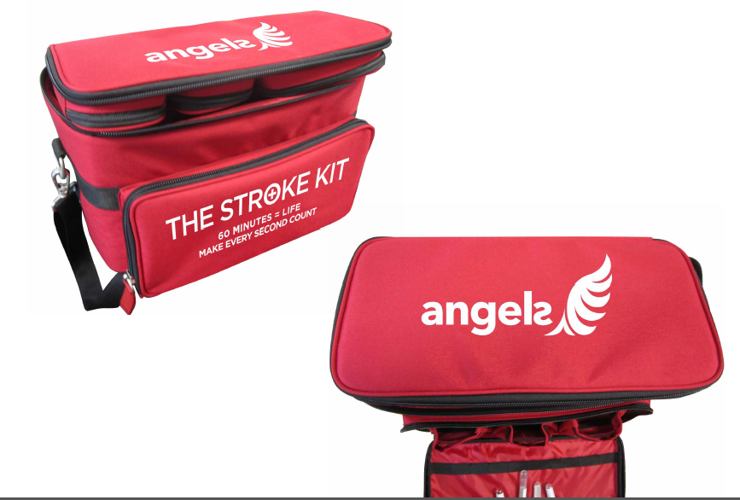

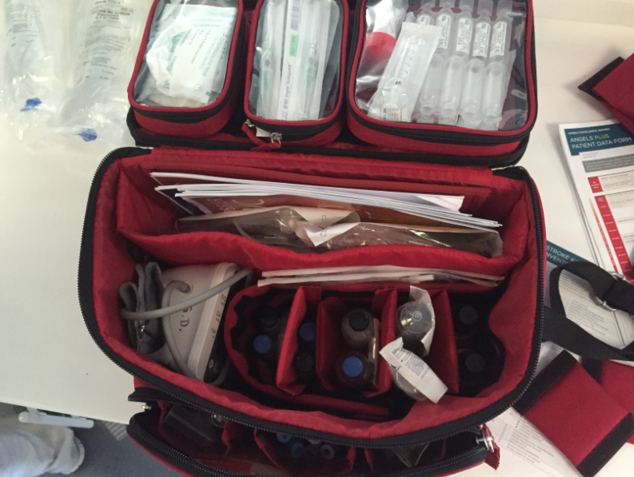

The only content that we will provide are paper protocols (if they don’t have their own), a stopwatch to measure the time of treatment, and wrist bands to put on patients so that every nurse that comes across patients in the next couple of days know to treat them differently. For example that patients should not be given intramuscular injections for 24 hours after thrombolysis or food before swallowing test have been performed. An example of these wristbands are below.

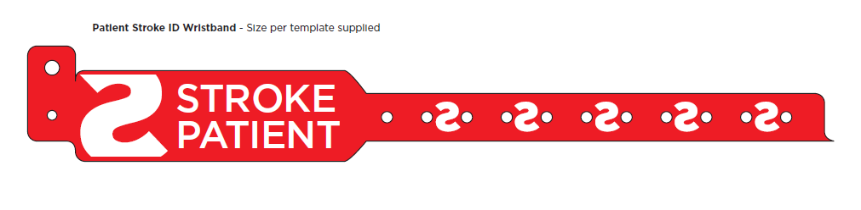

It is important to make clear that this stroke bag will not be given to individual HCP’s, but rather to hospitals as an item of medical utility to improve treatment of stroke. This falls under Article 9 of the EFPIA HCP code.

ARTICLE 9

INFORMATIONAL OR EDUCATIONAL MATERIALS AND ITEMS OF MEDICAL UTILITY

Section 9.01. The transmission of informational or educational materials is permitted provided it is:

1. “inexpensive”;
2. directly relevant to the practice of medicine or pharmacy; and
3. directly beneficial to the care of patients.

The transmission of such materials or items shall not constitute an inducement to recommend, prescribe, purchase, supply, sell or administer a Medicinal Product.

Section 11.01. of the EFPIA HCP code is also applicable as this is a grant to the hospital as part of a Healthcare improvement project and will be reported by BI Corporate on an annual basis as amount per hospital per year.

Section 11.01.

Donations and grants (in cash or in kind or otherwise) to institutions, organisations or associations that are comprised of healthcare professionals and/or that provide healthcare or conduct research (that are not otherwise covered by the EFPIA HCP Code or the EFPIA PO Code are only allowed if:

1. they are made for the purpose of supporting healthcare or research;
2. they are documented and kept on record by the donor/grantor; and
3. they do not constitute an inducement to recommend, prescribe, purchase, supply, sell or administer specific medicinal products.

It is important to keep in mind that using the stroke bag will not have any influence on how much of a specific treatment is given. Hospitals will treat their patients anyway based on their own decisions. What this does affect is how soon patients are treated.