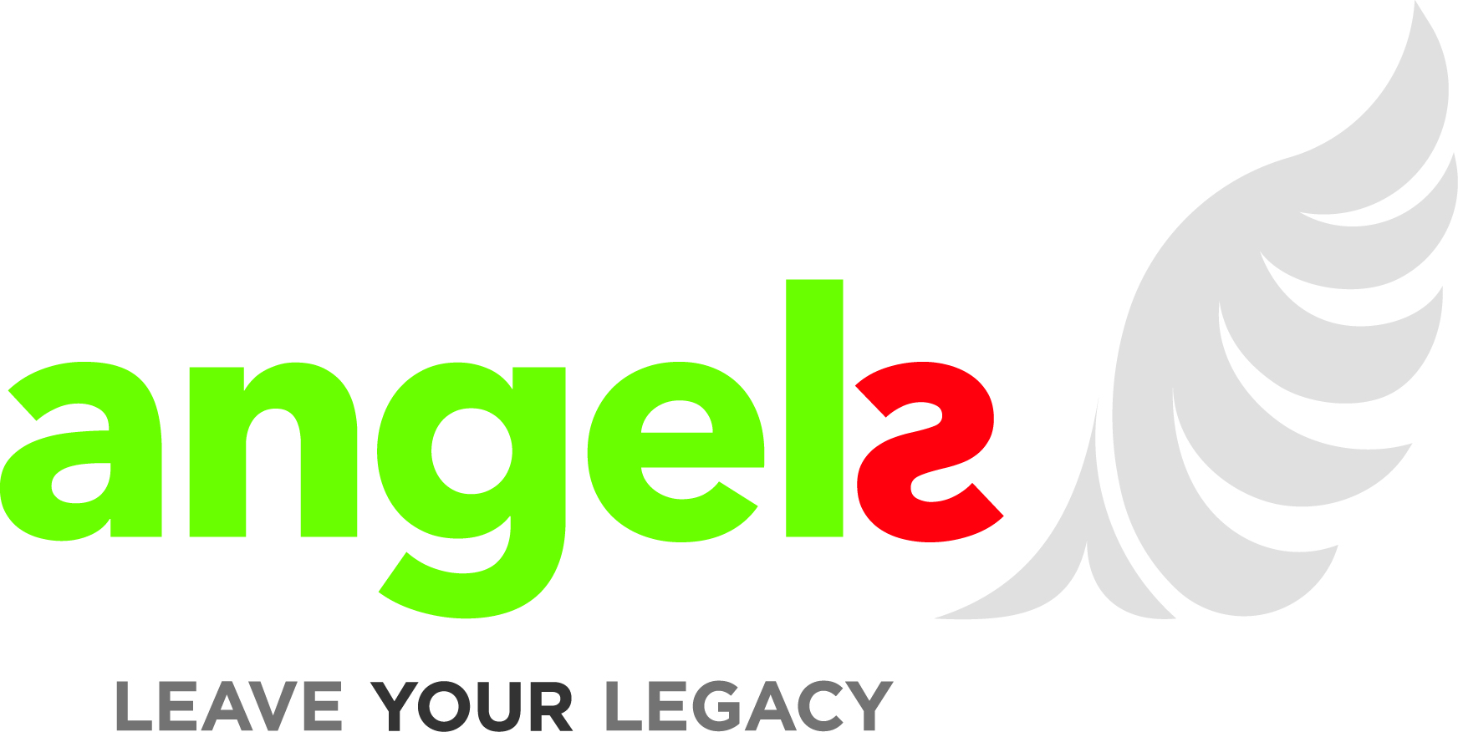
ANGELS INITIATIVE

ENROLMENT FORM

HOSPITAL NAME:
Print or type the legal name of your hospital

HOSPITAL ADDRESS: Print or type the postal address of your hospital

The Angels Initiative is intended for the support of healthcare and does not constitute an inducement to recommend, prescribe, purchase, supply, sell or administer specific medicinal products.

I understand that the Angels Initiative startup kit including, but not limited to the Stroke Bag and first set of documents is provided free of charge to the hospital, costs will be covered by Boehringer Ingelheim as a donation to your hospital. I understand all medical products contained in the Stroke Bag are to be provided by my hospital, and additional forms and documents are my responsibility once the setup kits are used. I understand that the costs of the Angels Consultants (employed by Quintiles) will be covered by Boehringer Ingelheim. I understand that Boehringer Ingelheim will report costs incurred for transparency under EFPIA and local regulations as amount per hospital/per country.

I understand that no action or omission by the Angels Consultants or any other third party used within the program will create any liability towards Boehringer Ingelheim. I understand that if my hospital desires to implement proposals detailed within the initiative or any other platform, it happens at the hospital’s own risk and without liability of Boehringer Ingelheim.

I have read and agreed to the above Terms and Conditions

I have authority to sign on behalf of my hospital



Hospital Representative Printed Name Title

Hospital Representative Signature Date

Phone Number Email Address

